Potop Adrian TSRC-251 TKINTER

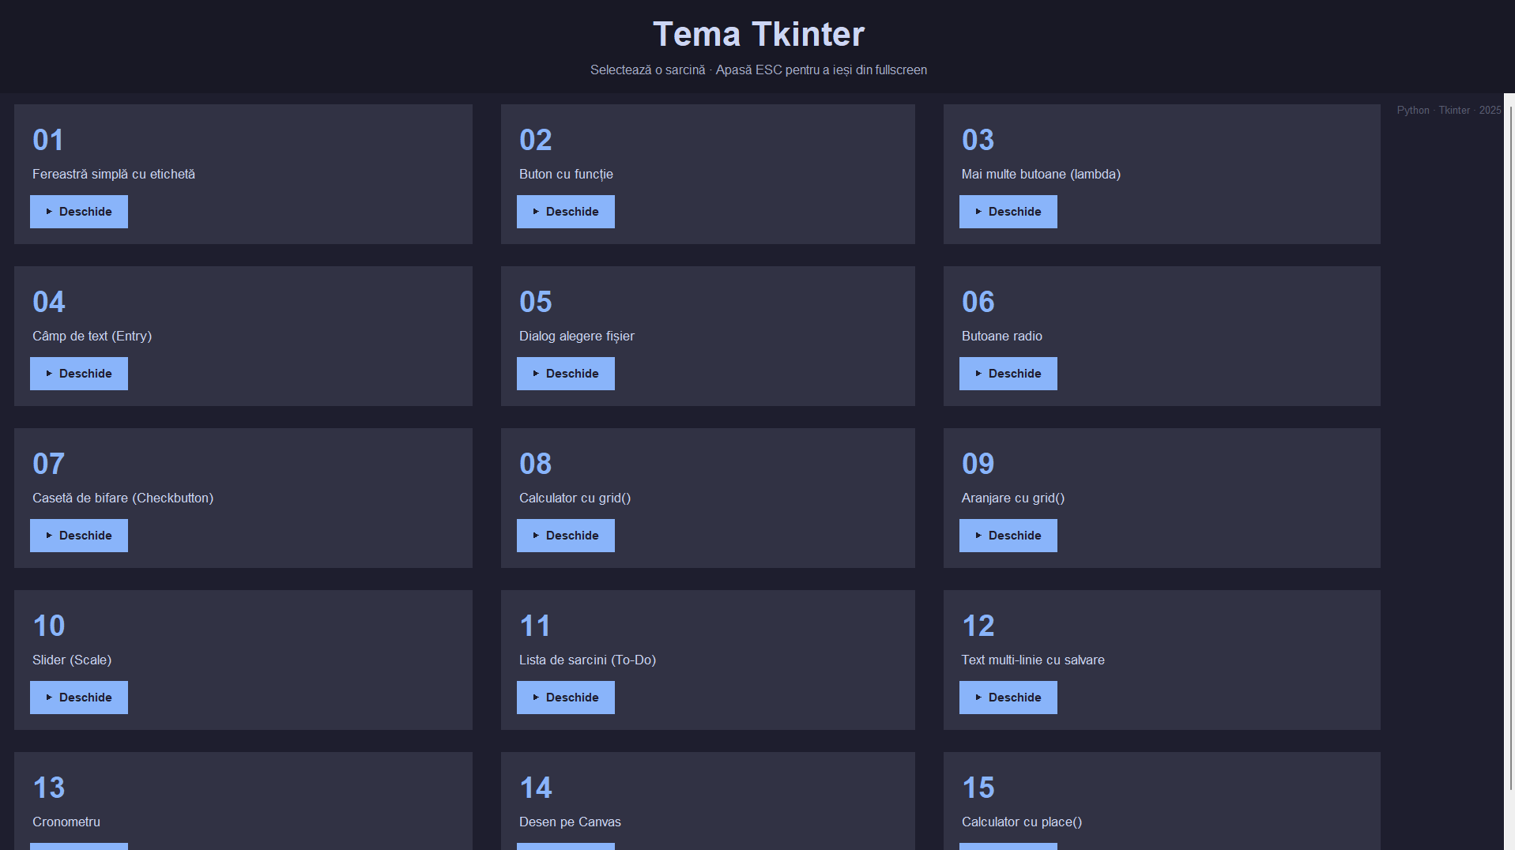
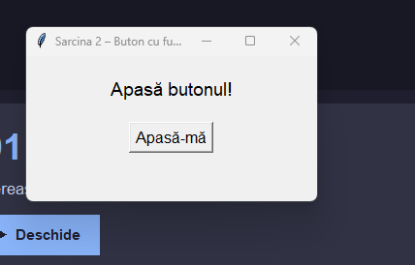
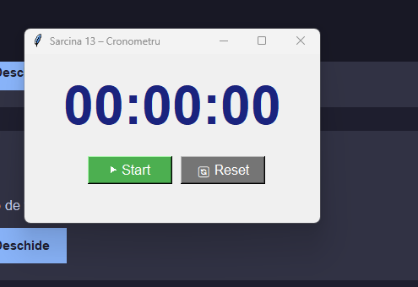
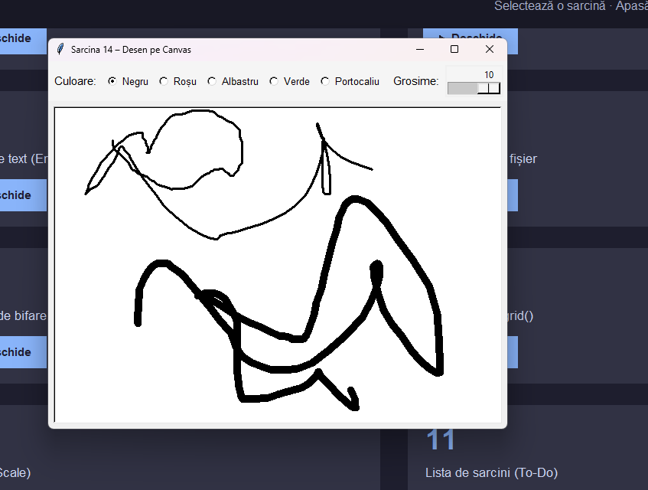

Codul acestei programe:
import tkinter as tk
from tkinter import filedialog, messagebox

# ─────────────────────────────────────────────
# SARCINA 1 – Fereastră simplă cu etichetă
# ─────────────────────────────────────────────
def sarcina_1():
win = tk.Toplevel()
win.title("Sarcina 1 – Etichetă simplă")
win.geometry("300x150")
tk.Label(win, text="Salut, lume!", font=("Arial", 16)).pack(pady=40)

# ─────────────────────────────────────────────
# SARCINA 2 – Buton cu funcție
# ─────────────────────────────────────────────
def sarcina_2():
win = tk.Toplevel()
win.title("Sarcina 2 – Buton cu funcție")
win.geometry("300x150")

eticheta = tk.Label(win, text="Apasă butonul!", font=("Arial", 14))
eticheta.pack(pady=20)

def la_apasare():
eticheta.config(text="Buton apăsat!")

tk.Button(win, text="Apasă-mă", command=la_apasare, font=("Arial", 12)).pack()

# ─────────────────────────────────────────────
# SARCINA 3 – Mai multe butoane cu lambda
# ─────────────────────────────────────────────
def sarcina_3():
win = tk.Toplevel()
win.title("Sarcina 3 – Cinci butoane")
win.geometry("380x150")

eticheta = tk.Label(win, text="Apasă un buton!", font=("Arial", 14))
eticheta.pack(pady=15)

frame = tk.Frame(win)
frame.pack()
for i in range(1, 6):
tk.Button(
frame, text=f"Buton {i}", font=("Arial", 12), width=8,
command=lambda n=i: eticheta.config(text=f"Ai apăsat butonul {n}")
).pack(side=tk.LEFT, padx=5)

# ─────────────────────────────────────────────
# SARCINA 4 – Câmp de text Entry
# ─────────────────────────────────────────────
def sarcina_4():
win = tk.Toplevel()
win.title("Sarcina 4 – Câmp de introducere text")
win.geometry("350x200")

tk.Label(win, text="Introdu un text:", font=("Arial", 12)).pack(pady=10)
camp = tk.Entry(win, font=("Arial", 12), width=25)
camp.pack(pady=5)

eticheta = tk.Label(win, text="", font=("Arial", 12), fg="blue")
eticheta.pack(pady=5)

tk.Button(
win, text="Afișează", font=("Arial", 12),
command=lambda: eticheta.config(text=f"Ai introdus: {camp.get()}")
).pack()

# ─────────────────────────────────────────────
# SARCINA 5 – Dialog alegere fișier
# ─────────────────────────────────────────────
def sarcina_5():
win = tk.Toplevel()
win.title("Sarcina 5 – Dialog fișier")
win.geometry("500x150")

eticheta = tk.Label(win, text="Calea fișierului va apărea aici.",
font=("Arial", 10), wraplength=460)
eticheta.pack(pady=20)

def alege():
cale = filedialog.askopenfilename(title="Selectează un fișier")
eticheta.config(text=cale if cale else "Niciun fișier selectat.")

tk.Button(win, text="Alege fișier", command=alege, font=("Arial", 12)).pack()

# ─────────────────────────────────────────────
# SARCINA 6 – Butoane radio
# ─────────────────────────────────────────────
def sarcina_6():
win = tk.Toplevel()
win.title("Sarcina 6 – Butoane radio")
win.geometry("300x270")

optiune = tk.StringVar(value="")
tk.Label(win, text="Alege un fruct:", font=("Arial", 13, "bold")).pack(pady=10)
for fruct in ["Măr", "Banană", "Portocală", "Căpșună"]:
tk.Radiobutton(win, text=fruct, variable=optiune,
value=fruct, font=("Arial", 12)).pack(anchor=tk.W, padx=60)

eticheta = tk.Label(win, text="", font=("Arial", 12), fg="green")
eticheta.pack(pady=5)

tk.Button(
win, text="Afișează", font=("Arial", 11),
command=lambda: eticheta.config(text=f"Ai ales: {optiune.get()}")
).pack()

# ─────────────────────────────────────────────
# SARCINA 7 – Casetă de bifare Checkbutton
# ─────────────────────────────────────────────
def sarcina_7():
win = tk.Toplevel()
win.title("Sarcina 7 – Casetă de bifare")
win.geometry("300x180")

stare = tk.IntVar()
eticheta = tk.Label(win, text="Caseta este NEBIFATĂ ✗",
font=("Arial", 12), fg="red")
eticheta.pack(pady=20)

def actualizeaza():
if stare.get():
eticheta.config(text="Caseta este BIFATĂ ✓", fg="green")
else:
eticheta.config(text="Caseta este NEBIFATĂ ✗", fg="red")

tk.Checkbutton(win, text="Bifează-mă!", variable=stare,
command=actualizeaza, font=("Arial", 13)).pack()

# ─────────────────────────────────────────────
# SARCINA 8 – Calculator cu grid()
# ─────────────────────────────────────────────
def sarcina_8():
win = tk.Toplevel()
win.title("Sarcina 8 – Calculator")
win.geometry("280x350")
win.resizable(False, False)

camp = tk.Entry(win, font=("Arial", 16), justify="right", bd=5)
camp.grid(row=0, column=0, columnspan=4, padx=10, pady=10, sticky="ew")

def apasa(s):
camp.insert(tk.END, s)

def calculeaza():
try:
rezultat = eval(camp.get())
camp.delete(0, tk.END)
camp.insert(0, str(rezultat))
except Exception:
camp.delete(0, tk.END)
camp.insert(0, "Eroare")

butoane = [
['7','8','9','/'],
['4','5','6','*'],
['1','2','3','-'],
['0','.','=','+'],
]
for r, rand in enumerate(butoane):
for c, s in enumerate(rand):
cmd = calculeaza if s == '=' else (lambda x=s: apasa(x))
bg = "#f0a500" if s in "+-*/" else ("#4caf50" if s == "=" else "#e0e0e0")
tk.Button(win, text=s, font=("Arial", 14), width=5, height=2,
bg=bg, command=cmd).grid(row=r+1, column=c, padx=3, pady=3)

tk.Button(win, text="C", font=("Arial", 14), width=22, height=2,
bg="#ef5350", fg="white",
command=lambda: camp.delete(0, tk.END)).grid(
row=5, column=0, columnspan=4, padx=3, pady=3)

# ─────────────────────────────────────────────
# SARCINA 9 – Aranjare cu grid()
# ─────────────────────────────────────────────
def sarcina_9():
win = tk.Toplevel()
win.title("Sarcina 9 – Aranjare cu grid()")
win.geometry("350x350")

eticheta = tk.Label(win, text="Apasă un buton!", font=("Arial", 13))
eticheta.grid(row=0, column=0, columnspan=3, pady=15)

for i, nr in enumerate(range(1, 10)):
tk.Button(
win, text=str(nr), font=("Arial", 14), width=6, height=2,
command=lambda n=nr: eticheta.config(text=f"Ai apăsat butonul {n}")
).grid(row=(i // 3) + 1, column=i % 3, padx=5, pady=5)

# ─────────────────────────────────────────────
# SARCINA 10 – Slider (Scale)
# ─────────────────────────────────────────────
def sarcina_10():
win = tk.Toplevel()
win.title("Sarcina 10 – Slider")
win.geometry("400x180")

tk.Label(win, text="Alege o valoare:", font=("Arial", 13)).pack(pady=10)
eticheta = tk.Label(win, text="Valoarea aleasă: 0", font=("Arial", 13), fg="blue")
eticheta.pack(pady=5)

def actualizeaza(val):
eticheta.config(text=f"Valoarea aleasă: {int(float(val))}")

tk.Scale(win, from_=0, to=100, orient=tk.HORIZONTAL,
length=300, font=("Arial", 11), command=actualizeaza).pack(pady=5)

# ─────────────────────────────────────────────
# SARCINA 11 – To-Do List
# ─────────────────────────────────────────────
def sarcina_11():
win = tk.Toplevel()
win.title("Sarcina 11 – Lista de sarcini")
win.geometry("400x360")

tk.Label(win, text="📝 Lista de sarcini", font=("Arial", 15, "bold")).pack(pady=8)

frame_sus = tk.Frame(win)
frame_sus.pack(pady=4)
camp = tk.Entry(frame_sus, font=("Arial", 12), width=25)
camp.pack(side=tk.LEFT, padx=5)

lista = tk.Listbox(win, font=("Arial", 12), width=40, height=10,
selectbackground="#90caf9")
lista.pack(pady=8, padx=10)

def adauga():
text = camp.get().strip()
if text:
lista.insert(tk.END, text)
camp.delete(0, tk.END)
else:
messagebox.showwarning("Atenție", "Introduceți o sarcină!", parent=win)

def sterge():
sel = lista.curselection()
if sel:
lista.delete(sel[0])
else:
messagebox.showwarning("Atenție", "Selectați o sarcină!", parent=win)

tk.Button(frame_sus, text="Adaugă", font=("Arial", 11),
bg="#4caf50", fg="white", command=adauga).pack(side=tk.LEFT)
tk.Button(win, text="Șterge selectat", font=("Arial", 11),
bg="#ef5350", fg="white", command=sterge).pack()

# ─────────────────────────────────────────────
# SARCINA 12 – Text multi-linie cu salvare
# ─────────────────────────────────────────────
def sarcina_12():
win = tk.Toplevel()
win.title("Sarcina 12 – Editor text")
win.geometry("500x380")

tk.Label(win, text="Editor text:", font=("Arial", 13, "bold")).pack(pady=5)
zona_text = tk.Text(win, font=("Arial", 12), width=55, height=15,
wrap=tk.WORD, bd=2, relief=tk.SUNKEN)
zona_text.pack(padx=10, pady=5)
zona_text.insert("1.0", "Scrie ceva aici...\n")

def salveaza():
continut = zona_text.get("1.0", tk.END)
cale = filedialog.asksaveasfilename(
defaultextension=".txt",
filetypes=[("Fișiere text", "*.txt")],
title="Salvează fișierul", parent=win)
if cale:
with open(cale, "w", encoding="utf-8") as f:
f.write(continut)
messagebox.showinfo("Succes", f"Salvat la:\n{cale}", parent=win)

tk.Button(win, text="💾 Salvează în fișier", font=("Arial", 12),
bg="#1976d2", fg="white", command=salveaza).pack(pady=8)

# ─────────────────────────────────────────────
# SARCINA 13 – Cronometru
# ─────────────────────────────────────────────
def sarcina_13():
win = tk.Toplevel()
win.title("Sarcina 13 – Cronometru")
win.geometry("350x200")

stare = {"ore": 0, "minute": 0, "secunde": 0, "pornit": False, "job": None}

eticheta = tk.Label(win, text="00:00:00", font=("Arial", 48, "bold"), fg="#1a237e")
eticheta.pack(pady=20)

def actualizeaza():
stare["secunde"] += 1
if stare["secunde"] == 60:
stare["secunde"] = 0
stare["minute"] += 1
if stare["minute"] == 60:
stare["minute"] = 0
stare["ore"] += 1
eticheta.config(text=f"{stare['ore']:02d}:{stare['minute']:02d}:{stare['secunde']:02d}")
if stare["pornit"]:
stare["job"] = win.after(1000, actualizeaza)

def porneste_opreste():
stare["pornit"] = not stare["pornit"]
if stare["pornit"]:
buton_start.config(text="⏸ Pauză", bg="#ef5350")
actualizeaza()
else:
buton_start.config(text="▶ Start", bg="#4caf50")
if stare["job"]:
win.after_cancel(stare["job"])

def reseteaza():
stare.update({"ore": 0, "minute": 0, "secunde": 0, "pornit": False})
if stare["job"]:
win.after_cancel(stare["job"])
eticheta.config(text="00:00:00")
buton_start.config(text="▶ Start", bg="#4caf50")

frame = tk.Frame(win)
frame.pack()
buton_start = tk.Button(frame, text="▶ Start", font=("Arial", 13),
bg="#4caf50", fg="white", width=10, command=porneste_opreste)
buton_start.pack(side=tk.LEFT, padx=10)
tk.Button(frame, text="🔄 Reset", font=("Arial", 13),
bg="#757575", fg="white", width=10, command=reseteaza).pack(side=tk.LEFT)

# ─────────────────────────────────────────────
# SARCINA 14 – Canvas pentru desen
# ─────────────────────────────────────────────
def sarcina_14():
win = tk.Toplevel()
win.title("Sarcina 14 – Desen pe Canvas")
win.geometry("600x480")

stare = {"x": None, "y": None}

bara = tk.Frame(win, bg="#f5f5f5", pady=5)
bara.pack(fill=tk.X)

culoare_curenta = tk.StringVar(value="black")
tk.Label(bara, text="Culoare:", bg="#f5f5f5", font=("Arial", 11)).pack(side=tk.LEFT, padx=5)
for nume, val in [("Negru","black"),("Roșu","red"),("Albastru","blue"),
("Verde","green"),("Portocaliu","orange")]:
tk.Radiobutton(bara, text=nume, variable=culoare_curenta, value=val,
bg="#f5f5f5", font=("Arial", 10)).pack(side=tk.LEFT, padx=2)

tk.Label(bara, text=" Grosime:", bg="#f5f5f5", font=("Arial", 11)).pack(side=tk.LEFT)
grosime = tk.Scale(bara, from_=1, to=10, orient=tk.HORIZONTAL,
length=80, bg="#f5f5f5", showvalue=True)
grosime.set(3)
grosime.pack(side=tk.LEFT, padx=5)

canvas = tk.Canvas(win, bg="white", cursor="crosshair",
width=600, height=420, bd=2, relief=tk.SUNKEN)
canvas.pack(padx=5, pady=5)

tk.Button(bara, text="🗑 Șterge", font=("Arial", 10), bg="#ef5350", fg="white",
command=lambda: canvas.delete("all")).pack(side=tk.RIGHT, padx=10)

def incepe(e):
stare["x"], stare["y"] = e.x, e.y

def deseneaza(e):
if stare["x"] is not None:
canvas.create_line(stare["x"], stare["y"], e.x, e.y,
fill=culoare_curenta.get(), width=int(grosime.get()),
smooth=True, capstyle=tk.ROUND, joinstyle=tk.ROUND)
stare["x"], stare["y"] = e.x, e.y

def opreste(e):
stare["x"] = stare["y"] = None

canvas.bind("<ButtonPress-1>", incepe)
canvas.bind("<B1-Motion>", deseneaza)
canvas.bind("<ButtonRelease-1>", opreste)

# ─────────────────────────────────────────────
# SARCINA 15 – Calculator cu place()
# ─────────────────────────────────────────────
def sarcina_15():
win = tk.Toplevel()
win.title("Sarcina 15 – Calculator cu place()")
win.geometry("300x385")
win.resizable(False, False)

camp = tk.Entry(win, font=("Arial", 18), justify="right", bd=4, relief=tk.SUNKEN)
camp.place(x=10, y=10, width=280, height=50)

def apasa(s):
camp.insert(tk.END, s)

def calculeaza():
try:
rezultat = eval(camp.get())
camp.delete(0, tk.END)
camp.insert(0, str(rezultat))
except Exception:
camp.delete(0, tk.END)
camp.insert(0, "Eroare")

layout = [
("7",10,70,60,55,"#e0e0e0"), ("8",80,70,60,55,"#e0e0e0"),
("9",150,70,60,55,"#e0e0e0"), ("/",220,70,70,55,"#f0a500"),
("4",10,135,60,55,"#e0e0e0"), ("5",80,135,60,55,"#e0e0e0"),
("6",150,135,60,55,"#e0e0e0"),("*",220,135,70,55,"#f0a500"),
("1",10,200,60,55,"#e0e0e0"), ("2",80,200,60,55,"#e0e0e0"),
("3",150,200,60,55,"#e0e0e0"),("-",220,200,70,55,"#f0a500"),
("0",10,265,130,55,"#e0e0e0"),(".",150,265,60,55,"#e0e0e0"),
("+",220,265,70,55,"#f0a500"),
("C",10,330,130,45,"#ef5350"),("=",150,330,140,45,"#4caf50"),
]
for (text, x, y, w, h, bg) in layout:
if text == "=": cmd = calculeaza
elif text == "C": cmd = lambda: camp.delete(0, tk.END)
else: cmd = lambda s=text: apasa(s)
tk.Button(win, text=text, font=("Arial", 16, "bold"),
bg=bg, relief=tk.RAISED, command=cmd).place(x=x, y=y, width=w, height=h)

# ═══════════════════════════════════════════════════════
# MENIU PRINCIPAL
# ═══════════════════════════════════════════════════════
SARCINI = [
(1, "Fereastră simplă cu etichetă", sarcina_1),
(2, "Buton cu funcție", sarcina_2),
(3, "Mai multe butoane (lambda)", sarcina_3),
(4, "Câmp de text (Entry)", sarcina_4),
(5, "Dialog alegere fișier", sarcina_5),
(6, "Butoane radio", sarcina_6),
(7, "Casetă de bifare (Checkbutton)", sarcina_7),
(8, "Calculator cu grid()", sarcina_8),
(9, "Aranjare cu grid()", sarcina_9),
(10, "Slider (Scale)", sarcina_10),
(11, "Lista de sarcini (To-Do)", sarcina_11),
(12, "Text multi-linie cu salvare", sarcina_12),
(13, "Cronometru", sarcina_13),
(14, "Desen pe Canvas", sarcina_14),
(15, "Calculator cu place()", sarcina_15),
]

root = tk.Tk()
root.title("🐍 Tema Tkinter – Toate sarcinile")
root.attributes("-fullscreen", True)
root.configure(bg="#1e1e2e")

# ESC iese din fullscreen
def toggle_fullscreen(e=None):
root.attributes("-fullscreen", False)

root.bind("<Escape>", toggle_fullscreen)

# ── Header ──────────────────────────────────────────────
header = tk.Frame(root, bg="#181825", pady=18)
header.pack(fill=tk.X)

tk.Label(header, text="Tema Tkinter",
font=("Arial", 32, "bold"), fg="#cdd6f4", bg="#181825").pack()
tk.Label(header, text="Selectează o sarcină · Apasă ESC pentru a ieși din fullscreen",
font=("Arial", 12), fg="#a6adc8", bg="#181825").pack(pady=(4, 0))

# ── Grilă cu 3 coloane ──────────────────────────────────
canvas_scroll = tk.Canvas(root, bg="#1e1e2e", highlightthickness=0)
scrollbar = tk.Scrollbar(root, orient="vertical", command=canvas_scroll.yview)
canvas_scroll.configure(yscrollcommand=scrollbar.set)

scrollbar.pack(side=tk.RIGHT, fill=tk.Y)
canvas_scroll.pack(side=tk.LEFT, fill=tk.BOTH, expand=True)

frame_interior = tk.Frame(canvas_scroll, bg="#1e1e2e")
frame_window = canvas_scroll.create_window((0, 0), window=frame_interior, anchor="nw")

def on_resize(e):
canvas_scroll.itemconfig(frame_window, width=e.width)

def on_frame_configure(e):
canvas_scroll.configure(scrollregion=canvas_scroll.bbox("all"))

canvas_scroll.bind("<Configure>", on_resize)
frame_interior.bind("<Configure>", on_frame_configure)

# Mouse wheel scroll
def on_mousewheel(e):
canvas_scroll.yview_scroll(int(-1 * (e.delta / 120)), "units")

canvas_scroll.bind_all("<MouseWheel>", on_mousewheel)

# Construiește cardurile în grilă 3 coloane
COLS = 3
for idx, (nr, titlu, fn) in enumerate(SARCINI):
rand = idx // COLS
col = idx % COLS

card = tk.Frame(frame_interior, bg="#313244", padx=20, pady=20,
relief=tk.FLAT, bd=0)
card.grid(row=rand, column=col, padx=18, pady=14, sticky="nsew")
frame_interior.columnconfigure(col, weight=1)

tk.Label(card, text=f"{nr:02d}", font=("Arial", 28, "bold"),
fg="#89b4fa", bg="#313244").pack(anchor="w")

tk.Label(card, text=titlu, font=("Arial", 13),
fg="#cdd6f4", bg="#313244", wraplength=280, justify="left").pack(
anchor="w", pady=(6, 14))

tk.Button(
card,
text="▶ Deschide",
font=("Arial", 11, "bold"),
fg="#1e1e2e",
bg="#89b4fa",
activebackground="#b4befe",
activeforeground="#1e1e2e",
relief=tk.FLAT,
cursor="hand2",
padx=14,
pady=6,
command=fn
).pack(anchor="w")

# ── Footer ──────────────────────────────────────────────
tk.Label(root, text="Python · Tkinter · 2025",
font=("Arial", 10), fg="#585b70", bg="#1e1e2e").pack(pady=10)

root.mainloop()

